Mobile Responsive web application:

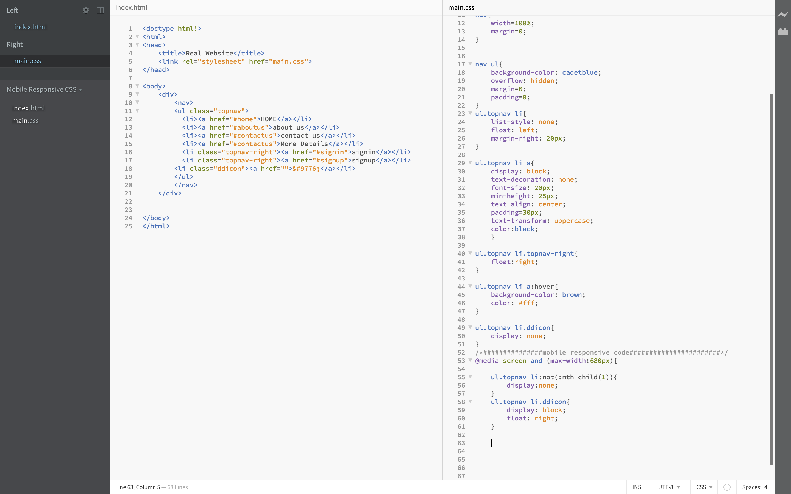

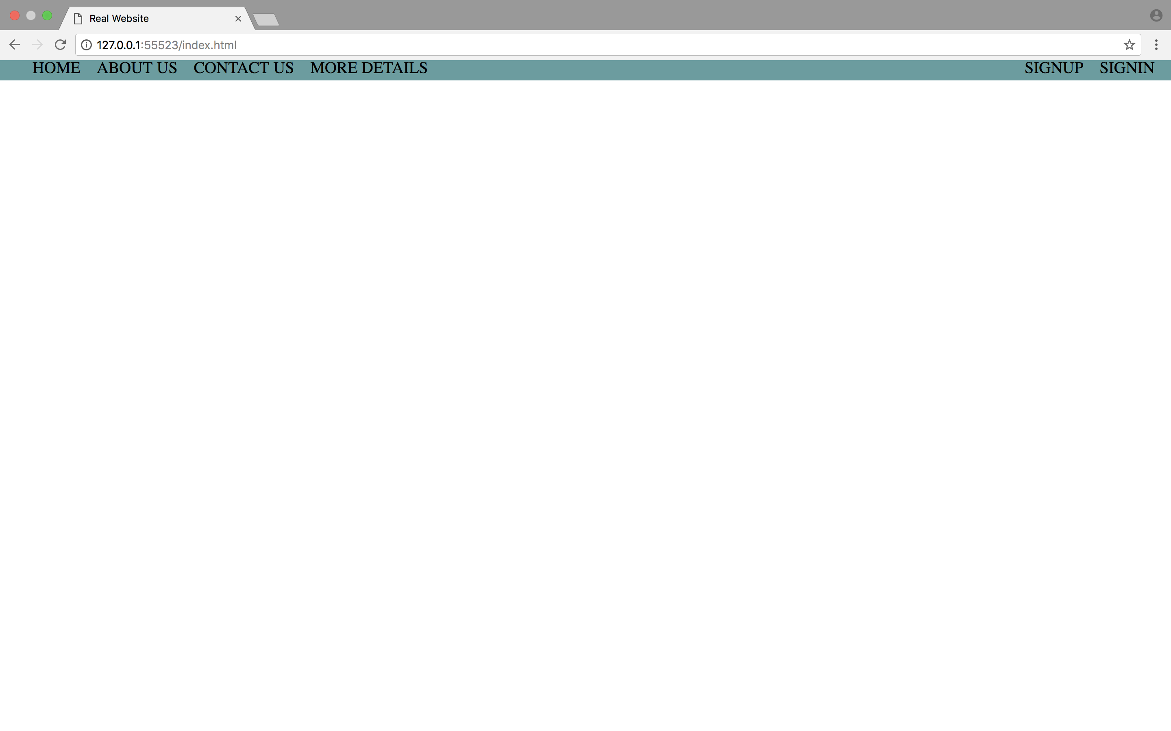

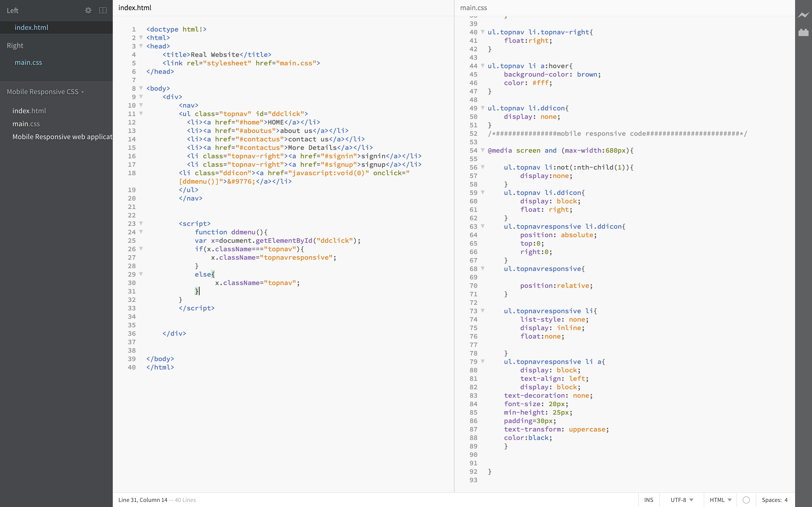

../../../../Desktop/Screen%20Shot%202018-02-17%20at%208.10.44%20

../../../../Desktop/Screen%20Shot%202018-02-17%20at%208.10.44%20